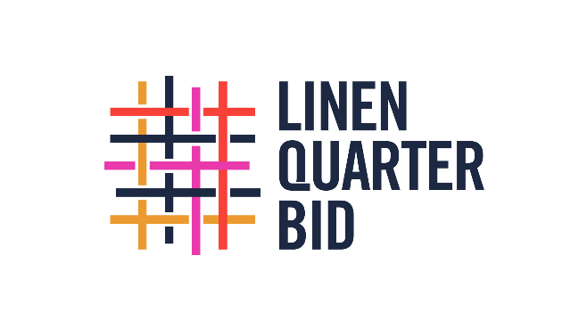
Vibrant District Fund
Application form

- About the applicant

Name of organisation | Contact person (incl position within organisation)
Adress | Email
 | Telephone

- Amount applied for (maximum £5.000,-)
(a more streamlined application will be available for small sums up to £1.000,-)

- About the proposal

A concise narrative outline of the proposed intervention

Location map

Please insert below
Details of suppliers / delivery partners and/or procurement process

Details of any proposed consultation and any permissions that are required

Timeline for delivery

Impact assessment outlining:
  - Public visibility / ability to interact
  - How the intervention will support the vibrancy of (i) the immediate and (ii) the wider District
  - Likely duration of the work and details of any maintenance programme

Total cost of the proposed work and outline of how the additional funding requested from LQ BID will improve the quality of the proposal

Notes:
- Interventions must be in the public realm or visible to the public. LQ BID cannot co-fund interventions within a member’s building.
- Applicants must be members of LQ BID and all levy payments must be up to date. If a business is not a member but wishes to obtain funding, they will need to become a voluntary member at £300.00 per annum (£150.00 per annum for registered charities).
- Interventions must be within LQ’s geographical boundary as outlined in the 2023-28 business plan.
- Linen Quarter BID can match fund an approved intervention up to a maximum of £5,000 per application.
- No formal procurement process is required for work up to £3,000. When commissioning work above this level, three written quotes from different suppliers are required (or evidence that a quote has been requested). If you wish to have an exemption from taking quotes (for example due to an existing contract) then this should be requested in advance in writing, with the reasons for the exemption highlighted.
- Sums up to £1,000 can be paid as a grant in advance. Funding over £1.000 will be paid in arrears following verification that the work has been completed and on the provision of invoices and bank records to show payment has been made.
- The Board are entitled to restrict funding to £5,000 per organisation per term, depending on available funds and demand. Total payments over the term will be capped at £100,000.
- LQ BID reserves the right to use photographs and social media content in relation to the installation.
- LQ BID should be credited/tagged in all social media or press releases issued by the member.

