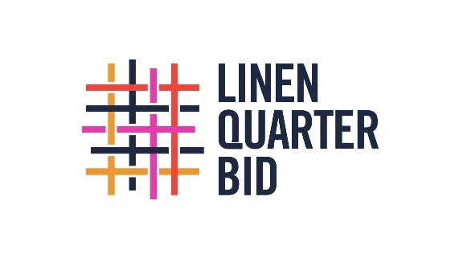

Expression of Interest: LQ BID Charity of the Year (2025-27) Application Form

Important Information:
- Application Open Date: 30th January 2025
- Application Closing Date: 31st March 2025
- Appointment: June 2025 - 2027
- Questions? Email: stephen@linenquarter.org

1. Charity Details:
- Name of Charity: ________________________________________________
- Postal Address: ___________________________________________________
- Registered Charity Number: _________________________________________

2. Main Contact(s) for This Application:
- Name: ___________________________________________________________
- Position/Role: _____________________________________________________
- Email Address: ____________________________________________________
- Phone Number: ___________________________________________________

3. A Brief Outline of What the Charity Does:
(Please summarize the mission and activities of the charity in no more than 250 words.)

4. Geographic Area of Operation:
- Please describe the geographic area in which your charity operates, with a specific focus on work carried out within or in support of those who live/work in or visit the Linen Quarter:

5. Reasons Why Your Charity Should Be Adopted as the Charity of the Year:
(Explain why your charity aligns with the goals and values of LQ BID including any potential benefits for the Linen Quarter community and how any funds raised may be used. Limit to 300 words.)

6. Can you demonstrate previous experience of success in charity partnerships, including how you’ve monitored and reported on success; and/or outline some activities you might like undertake if appointed LQ BID Charity of the Year 2025-2027?
(Provide examples of past successful charity or business partnerships or describe potential initiatives your charity might organize. Limit to 300 words.)

7. Additional Information (Optional):
Is there anything else you'd like us to consider as part of your application? (Max 150 words)

Declaration:
I confirm that the information provided in this application is accurate to the best of my knowledge.
- Name: ___________________________________________________________
- Signature: _______________________________________________________
- Date: ___________________________________________________________

Submission:
Please complete and return this form by email to stephen@linenquarter.org no later than 31st March 2025. Late submissions may not be considered.
Thank you for your interest in becoming LQ BIDs Charity of the Year!

